**In Class Activity 2**



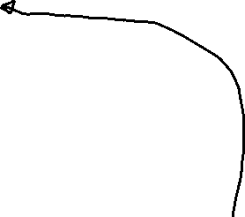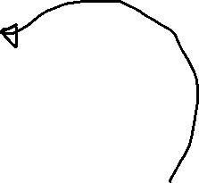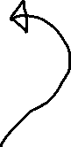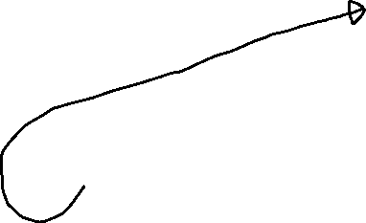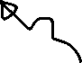

1) Label the following parts in the picture above: lungs, diaphragm, trachea, larynx, bronchi

2) Describe the difference between tidal and speech breathing in your own words.

Tidal speech is even patterned like a generic sine wave, while speech breathing is more like a gradual decrease in breath then a sudden inhale to increase breath again



3) Label the following parts of the larynx: epiglottis, trachea, cricoid cartilage, thyroid, cartilage, hyoid bone

4) For the vocal fold image, please label: vocal folds, trachea, glottis, epiglottis, ventricular folds (note that one label still needs a line, all others have already black lines pointing to their corresponding location).

larynx: epiglottis, trachea, cricoid cartilage, thyroid, cartilage, hyoid bone

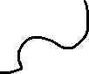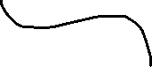

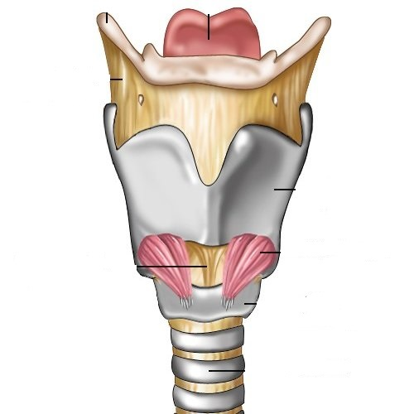

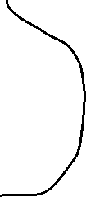

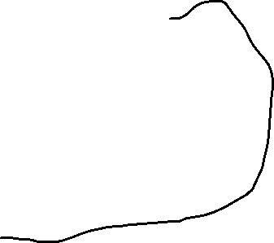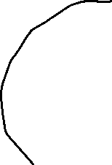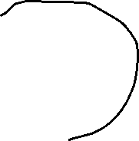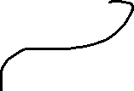

vocal folds, trachea, glottis, epiglottis, ventricular folds

5) What are parts of the CNS? What are parts of the PNS?

6) Label the following parts of the brain (you can draw lines to the corresponding parts, highlight them with color, or put numbers on the corresponding parts):

Frontal Lobe, Temporal Lobe, Parietal Lobe, Occipital Lobe, Cerebellum, Cerebrum, Brain Stem, Broca’s Area, Wernicke’s Area, Primary Motor Cortex, Auditory, Primary Auditory Cortex

